Module 4 (Task 1)

Task A (Document Design): Design a JSON document for an "Audiobook". Include: Title, Narrator, Duration, and Tags array.
Ans:-
{
"_id": {
"$oid": "69720c6f5f20054b729ffa96"
},
"Title": "The Lean Startup Vol 2",
"Narrator": "Sadhguru",
"Duration": "14:07:00",
"Tags": [
"startup",
"philosophy",
"success"
],
"project_type_id": "AudioBook"
}

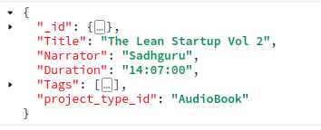

Task B (Embedding vs Referencing): Should "Reviews" be embedded in the Audiobook document or kept separate? Justify your choice for a read-heavy app.

Ans:-
For a read-heavy audiobook application, reviews can be stored in a separate collection and referenced using the audiobook_id. Although embedding reviews would make reads faster, the number of reviews per audiobook can grow without bounds. This would continuously increase the document size and may eventually hit MongoDB’s 16 MB document size limit.

Also, reviews are written and updated frequently by many users. If all reviews are embedded inside a single Audiobook document, every new review would update the same document, which can lead to write contention and poor performance.

By keeping reviews in a separate collection, the data model becomes more scalable, avoids large document growth, and allows efficient inserts, updates, and deletes of individual reviews. If needed, a small number of recent or top reviews can still be embedded for faster reads.

